Measuring Guide

Get the perfect fit with our easy to use size guide
Please use the following guidelines along with a fabric tape measure to be certain you are ordering the correct size. When taking your measurements, wear minimal or very light clothing to get the most accurate measurements.
Waist: Measure around your natural waistline, not holding the tape too snug and keeping one finger between tape and body. This is usually the narrowest point in your waist.

Waist
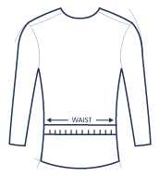
Hips: Stand with your heels together and measure around the fullest part of your hips.
Chest: Wrap the tape around the fullest part of your chest, keeping tape under arms pit and over the shoulder blade and level all the way round.

Chest
Chest Size
British & US Inches | 34 | 36 | 38 | 40 | 42 | 44 | 46 | 48 | 50 | 52 | 54
US inches | 34 | 36 | 38 | 40 | 42 | 44 | 46 | 48 | 50 | 52 | 54
Continental cm | 44 | 46 | 48 | 50 | 52 | 54 | 56 | 58 | 60 | 62 | 64
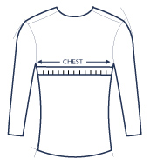
Neck: Measure around the middle of neck. Allow room for your index finger to fit between the tape and your neck for a comfortable fit. Ensure the tape measure is level all the way round. You can also take a shirt that fits you well. Lay collar flat and measure centre of collar button to far end of button hole. Number of inches = size.

Collar
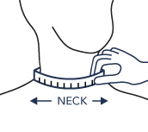
Collar Size | 14 | 14.5 | 15 | 15.5 | 16 | 16.5 | 17 | 17.5 | 18 | 18.5 | 19 | 19.5 | 20 | 20.5 | 21
CM | 36 | 37 | 38 | 39 | 41 | 42 | 43 | 44 | 46 | 47 | 48 | 49 | 51 | 52 | 53

Sleeves: Bend elbow and measure from centre of neck (back) to elbow down to wrist bone. Number of inches = size

Sleeve
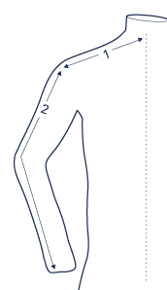
Inside leg: With the appropriate shoes on, measure from your crotch to your ankle bone where the trouser hem is to sit on the shoes or your desired trousers length, alternatively take a pair of trousers that fits well and measure from crutch seam to the bottom of trousers.

Inside leg
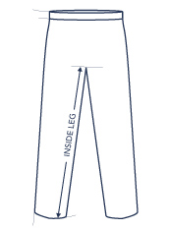
Hat Sizing
Hats: Measure around the circumference of the head with tape held snugly above brow ridges or well above the ears. Convert inches to hat size using the chart.

Hat Sizing
CM | 49CM | 50CM | 51CM | 52CM | 53CM | 54CM | 55CM | 56CM | 57CM | 58CM | 59CM | 60CM | 61CM | 62CM
UK SIZE | 6 | 6 1/8 | 6 1/4 | 6 3/8 | 6 1/2 | 6 5/8 | 6 3/4 | 6 7/8 | 7 | 7 1/8 | 7 1/4 | 7 3/8 | 7 1/2 | 7 5/8
US SIZE | 6 /8 | 6 1/4 | 6 3/8 | 6 1/2 | 6 5/8 | 6 3/4 | 6 7/8 | 7 | 7 1/8 | 7 1/4 | 7 3/8 | 7 1/2 | 7 5/8 | 7 3/4
INCHES | 19.3 | 19.7 | 20.1 | 20.5 | 20.9 | 21.3 | 21.7 | 22 | 22.4 | 22.8 | 23.2 | 23.6 | 24 | 24.4

Shoes Sizing
Shoes Size
British | 6 | 6.5 | 7 | 7.5 | 8 | 8.5 | 9 | 9.5 | 10 | 10.5 | 11 | 11.5 | 12 | 12.5 | 13
US | 6.5 | 7 | 7.5 | 8 | 8.5 | 9 | 9.5 | 10 | 10.5 | 11 | 11.5 | 12 | 12.5 | 13 | 13.5
Continental | 39.5 | 40 | 41 | 41.5 | 42 | 42.5 | 43 | 44 | 44.5 | 45 | 46 | 46.5 | 47 | 47.5 | 48
Measuring Guide for Correct Size
Hats: Measure around the head with the tape held snugly above eye above brow ridges. Convert inches to hat size using the chart.

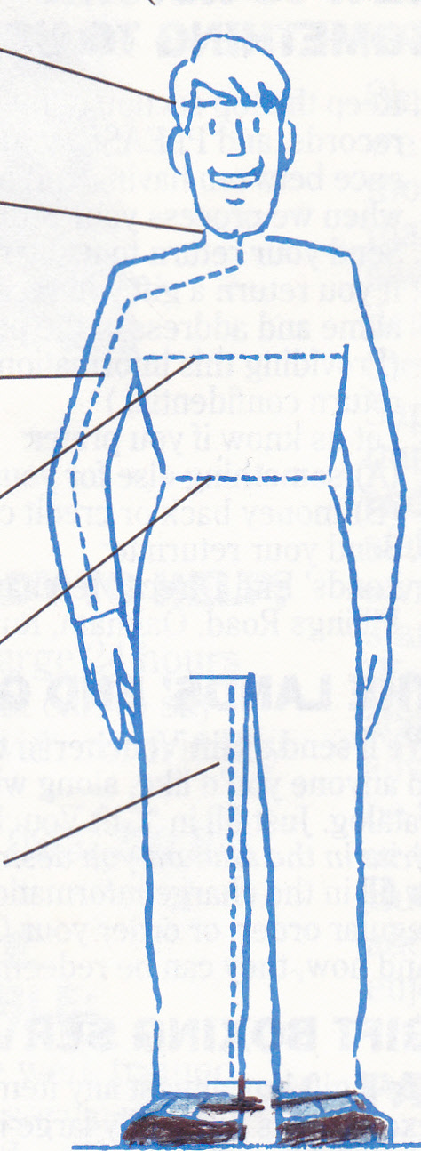
HEIGHT
ME ASUREMENT

Neck: Measure around the middle of neck. Allow room for your index finger to fit between the tape and your neck for a comfortable fit. You can also take a shirt that fits you well. Lay collar flat and measure centre of collar button to far end of button hole. Number of inches = size.

Measurement from crown of Head to the Floor = Height
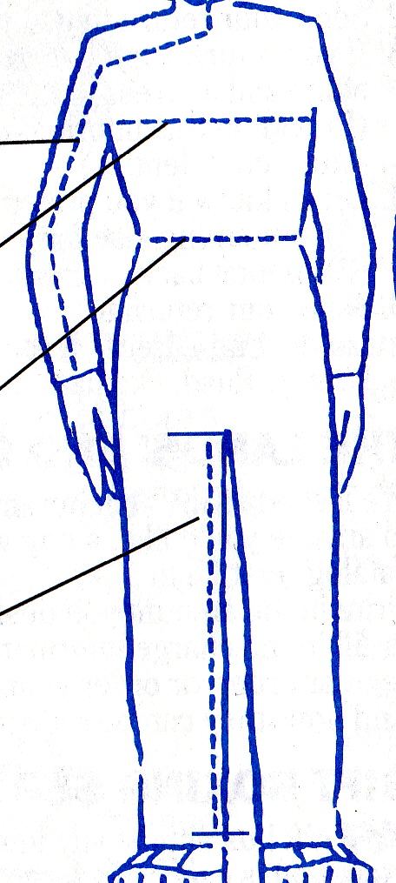
Arm: Bend elbow and measure from centre of neck (behind) to elbow down to wrist. Number of inches = size

Chest: Wrap the tape around the fullest part of your chest, keeping tape under arms and around shoulder blades.

Waist: Measure around your natural waistline, not holding the tape too snug and keeping one finger between tape and body. This is usually the narrowest point in your waist.

Inside leg: With the appropriate shoes on, measure from your crotch to your desired pant length, alternatively take a pair of trousers that fits well and measure from crutch seam to the bottom of trousers.

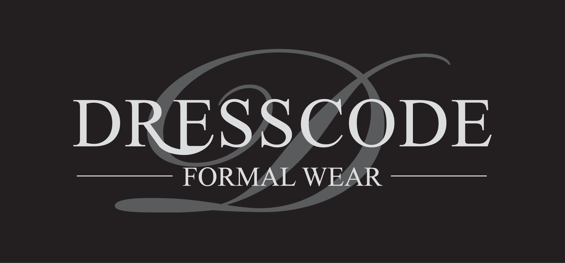
www.dresscodeformalwear.co.uk

