How to Tie a Windsor Knot – Bow Tie

- The Windsor knot is a double knot. Thus, you need a lot more length of the necktie to tie this knot. Therefore, make sure that the broad end of the tie hangs down much lower. Cross the wider end of the tie over the narrow end and hold in place with two fingers
- Then take the wide end of the tie and pull it through the loop on your neck. Then take the wide end and wrap it back behind the narrow end.
- Now take the wide end of the tie and pull it through the loop across from the side of the previous wrapping.
- Slightly tighten it, and pull the wide end back over the front of the knot. Don’t pull tight but create a loop.
- Pull the wide end of the tie through the loop at the front of the knot.
- Slightly tighten the knot. Make sure that the wide end of the tie lies centered and doesn’t fall into the crevice created of the two wrappings.
- Give the knot some final adjustment and flip down your collars. You are done tying the Double Windsor knot.
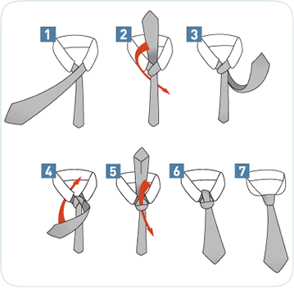

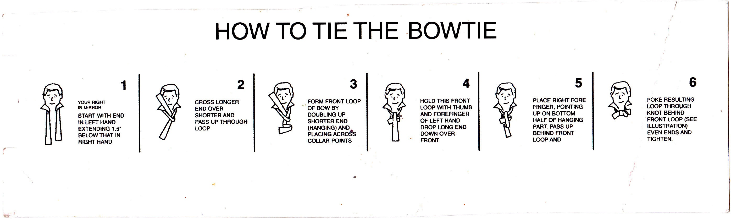

Useful Definition

French Cuffs = Double Cuff Shirt
Suspenders = Braces
Tuxedo = White/Ivory Jacket
Pants = Trousers
Vest = Waistcoat
Waist covering /Waistband = Cummerbund, worn with Single breasted Dinner Jacket
SB / DB Jacket = SB: Single Breasted / DB: Double Breasted
Black Tie Dress Code = Dinner Suit / Evening Wear
Smoking Jacket = Velvet/Silk Jacket (smooth fabric) used as Dinner Jacket
In the year 1800 the smoking jackets were designed for wealthy people to wear while smoking tobacco i.e. pipe or cigar

