Guide to Correct Etiquette
Please find below Guide to Correct Etiquette for that special Occasion. Always check what the invitation states or check with the host or with organiser if in doubt.
Morning Dress
The Invitation: If the invitation states Morning Suit/Lounge Suit either a Morning Tails or a smart business suit can be worn. Morning Suits are worn for the Weddings - Garden Parties, Royal Ascot, Trooping the Colour and State Funerals with a black waistcoat.
Weddings:
- Morning Coat: Grey/Black Classic Morning Tails/ ¾ Length Jacket / Frock Coat
- Trousers: Grey Stripe or Grey/ or Matching to Tails
- Traditional Grey/ Fancy waistcoats
- Shirts: Collar Attached/Wing Collar/ Victorian High Wing Shirt
- Grey/Fancy Tie/Cravat/Matching Hanky
- Grey Gloves/ Cuff Links / Braces Optional / Grey Top Hat
- Royal Ascot: Black/Grey Hat Mandatory for Royal Enclosure
- Black/Grey Morning Suit – Grey pin stripe/grey trousers
- White Shirt Collar Attached/Wing Collar Shirt/ Pastel Coloured shirts can also be worn
- Grey or Colour coordinated Tie/Cravat/Gloves Optional
Investiture:
- Black Top Hat – Black Morning Coat / Stripe Trousers /Lounge Suit
- Stripe Trousers
- Dark/Grey waistcoat - White Shirt – Dark Grey Tie
Royal Garden Party and Trooping the Colour
- Grey Top Hat – Black Morning Coat – Grey Waistcoat
- Stripe Trousers – White Shirt – Grey Tie
- National Dress and Uniform can also be worn
The Queen hosts at least three at Buckingham Palace, as well as one at the Palace in Edinburgh. Garden parties have been held at Buckingham Palace since the 1860s. An Investiture is a very special day when an individual who has been awarded an honour receives their award in person from The Queen, The Prince of Wales or sometimes The Princess Royal. Around 25 Investitures are held each year.

Evening Wear

Although the evening wear dress generally means Dinner Suits these days, there are many functions which require wearing of white tie and tails and are stated in the invite. Scottish Highland dress is often worn to black and white tie occasions. Dinner Suits are generally for Private and Public Dinner Parties, Proms, University Balls, Wedding Reception etc

White Tie Outfit
White Tie is worn at Royal Warrant Holders Dinner, Livery Company Dinners, State Banquets, Lord Mayors Dinner, Guild Dinners, Hunt Balls, Jewish Weddings, Some Cambridge & Oxford May Balls/ Commemorative Balls
- Black Evening Tails with satin or ribbed facing
- Black Trousers with satin braid down the side of the Trousers
- White Marcella waistcoat
- White Bow
- Black Socks
- Plain Black/ Patent Shoes
White Tie = If the invitation states the dress code is White Tie, it means a full white tie outfit consisting of evening tail coat and matching black trousers with white Marcella wing collar shirt, a white waistcoat and white bow

Dinner Suit / Black Tie

- The wearing of Dinner Suits is simple:
- The Dinner Jacket can be in variety of style: single or double breasted, peak, notch or shawl lapel with matching trousers with satin stripe on the side of legs.
- Waistcoat or Cummerbund with matching bow ready tied or self tie. Jazzy Colours can be worn for less formal functions. The cummerbund is derived from military dress uniform in India, worn with the pleats facing upwards. Cummerbund is a waist belt (Hindustani term: kamar- band) keeping the waist in after few drinks and eating that lovely food.
- Plain Black Socks and Black Shoes.
- Tuxedo refers to White/ Ivory Jacket made popular by Humphrey Bogart in the movie Casablanca. It is appropriate for warm climate evening function or on the Cruises. With a black trousers a white or black conventional or wing collar shirt and coordinating bow and a matching hanky gives that sharp look.
- Black Tie trousers are without turn-ups and belt loops, the outer seam s has a braid running down the side of trousers.

How to Tie a Windsor Knot

- The Windsor knot is a double knot. Thus, you need a lot more length of the necktie to tie this knot. Therefore, make sure that the broad end of the tie hangs down much lower. Cross the wider end of the tie over the narrow end and hold in place with two fingers
- Then take the wide end of the tie and pull it through the loop on your neck. Then take the wide end and wrap it back behind the narrow end.
- Now take the wide end of the tie and pull it through the loop across from the side of the previous wrapping.
- Slightly tighten it, and pull the wide end back over the front of the knot. Don’t pull tight but create a loop.
- Pull the wide end of the tie through the loop at the front of the knot.
- Slightly tighten the knot. Make sure that the wide end of the tie lies centered and doesn’t fall into the crevice created of the two wrappings.
- Give the knot some final adjustment and flip down your collars. You are done tying the Double Windsor knot.
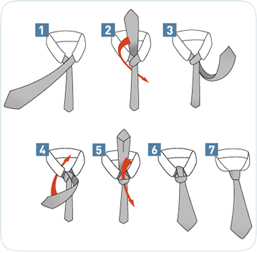
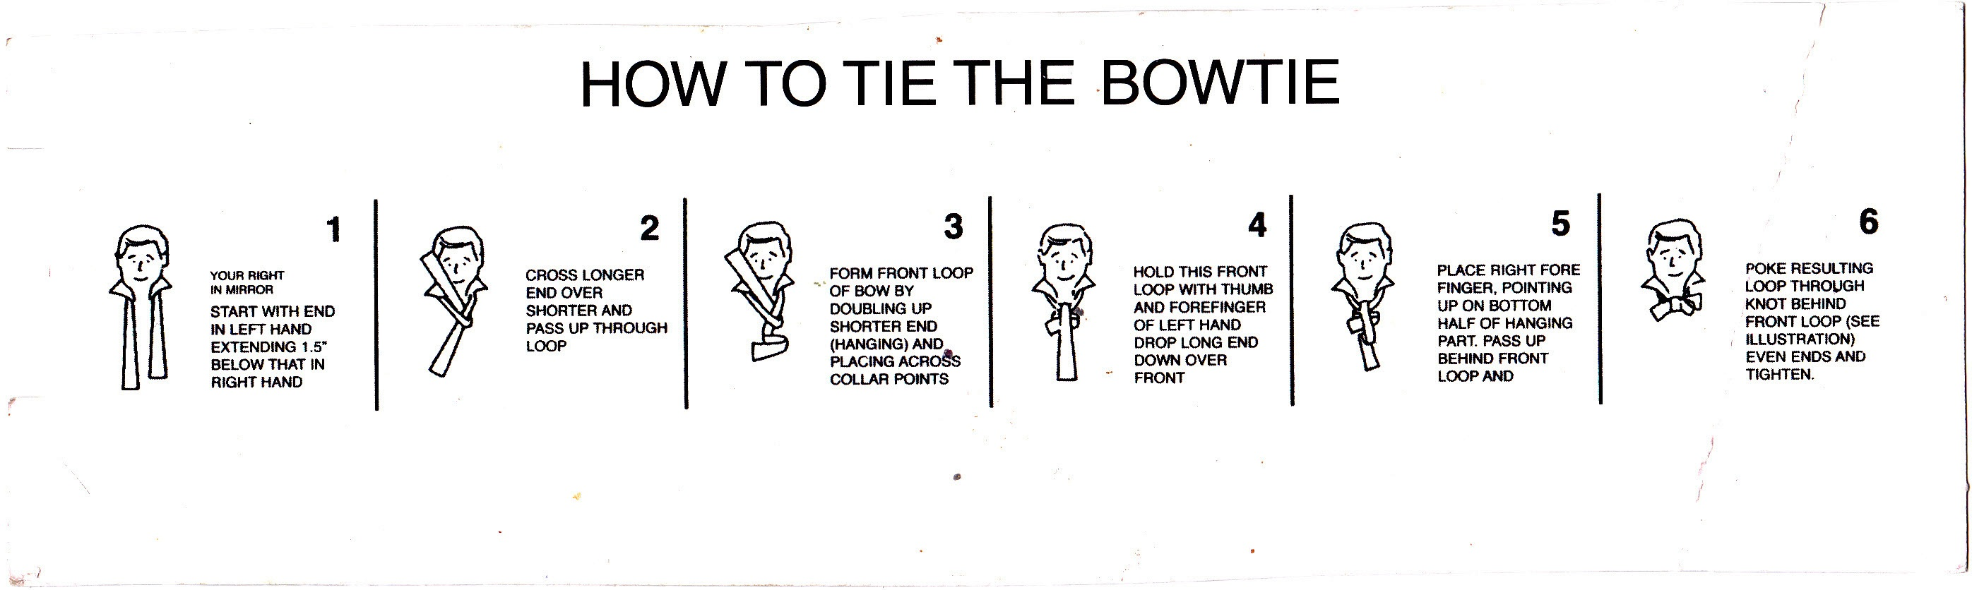

Useful Definition

French Cuffs = Double Cuff Shirt
Suspenders = Braces
Tuxedo = White/Ivory Jacket
Pants = Trousers
Vest = Waistcoat
Waist covering /Waistband = Cummerbund, worn with Single breasted Dinner Jacket
SB / DB Jacket = SB: Single Breasted / DB: Double Breasted
Black Tie Dress Code = Dinner Suit / Evening Wear
Smoking Jacket = Velvet/Silk Jacket (smooth fabric) used as Dinner Jacket
In the year 1800 the smoking jackets were designed for wealthy people to wear while smoking tobacco i.e. pipe or cigar

